

**KABARAK UNIVERSITY**

**SCHOOL OF SCIENCE, ENGINEERING AND TECHNOLOGY**

**DEPARTMENT OF COMPUTER SCIENCE AND IT**

**BACHELOR OF SCIENCE IN INFORMATION TECHNOLOGY**

**PROJECT II**

**PROJECT TITLE: BOMET COUNTY BANANA FARMERS’ MARKET**

**A Project Submitted to the School of Science, Engineering and Technology in Partial Fulfilment of the Requirements for the Award of the Degree of Bachelor of Science in Information Technology**

**KORIR JAPHETH KIBET INTE/M/3158/09/18**

**SUPERVISOR: MR. CLEOPHAS MOCHOGE**

**DECLARATION**

I hereby declare that this project documentation is my original work and has not been submitted for any academic award in any other university or institution. All sources used in this project have been duly acknowledged.

Sign: ________________________ Date: ________________________

**RECOMMENDATION**

This Project entitled **Bomet County Banana Farmers’ Market** written by Korir Japheth Kibet is presented to the School of Science, Engineering and Technology of Kabarak University. We have reviewed this project and recommended it be accepted in partial fulfillment of the requirements for the Degree of Bachelor of Science in Information Technology.

Sign: ________________________ Date: ________________________

**Mr. Cleophas Mochoge**

**School of Science, Engineering and Technology**

**Department of Computer Science and Information Technology**

**Kabarak University**

**COPYRIGHT**

 No part of this project may be reproduced or transmitted in any form or by any means, electronic or mechanical, including photocopying, recording, or any information storage and retrieval system, without permission in writing from the author.

All Rights Reserved

©2024

Sign: ________________________ Date: ________________________

**ACKNOWLEDGEMENT**

I am grateful to each and every individual who has been part of the success of this project. In particular, I would like to extend my sincere gratitude to Mr. Cleophas Mochoge, whom without, this project would never have seen the light of day. I would also like to acknowledge my parents, David and Eva Kirui who provided all necessary support for me to undertake this. My brothers Hezron, Aron and Cleophas as well as my sister Salome, I will be forever indebted to you. A special mention to Emmanuel Koech, were it not for you, maybe I would never have gotten a chance to do this. Supreme of all, I would like to thank The Almighty God, who has seen me through in each and every step that I undertook in this project. All Glory and Honor belongs to You.

**DEDICATION**

I dedicate this project to my father, Mr. David Kirui. Your passion in modern agriculture inspired me to use my education to find a solution to one of the challenges that you face.

**Table of Contents**

**DECLARATION** II

**RECOMMENDATION** III

**COPYRIGHT** IV

**ACKNOWLEDGEMENT** V

**DEDICATION** VI

**List of Tables** IX

**List of Figures** X

**ABBREVIATIONS** XI

**ABSTRACT** XII

**CHAPTER ONE** 1

**1.1 Introduction** 1

**1.2 Background to the study** 1

**1.2.1 Current system** 3

**1.3 Statement of the problem** 3

**1.5.2 Research Questions** 4

**1.6.1 Modules** 5

**1.7 Justification for the Project** 5

**1.7.1 Feasibility study** 6

**1.8 Scope and limitation of the study** 6

**CHAPTER TWO** 7

**LITERATURE REVIEW** 7

**2.1 Introduction** 7

**2.3 The current system in use by banana farmers** 7

**2.4 Shortcomings of the current system** 8

**2.5 Ideal characteristics of a system that links farmers to traders** 8

**2.6 Design Framework** 9

**CHAPTER THREE** 9

**RESEARCH DESIGN AND METHODOLOGY** 9

**3.1 Introduction** 9

**3.2 Research Design** 10

**3.4 Population of the Study** 10

**3.5 Sampling procedure and sample size** 10

**3.5.1 Sampling Procedure** 10

**3.5.2 Sample size** 11

**3.6 Data Collection Procedure** 11

**3.7 System Development Methodology** 11

**3.8 System Analysis and Design** 12

**3.8.1 Context Diagram** 12

**3.8.2 Level 1 DFD** 13

CHAPTER 4 14

4.1 Introduction 14

4.2 System Architecture 14

4.3 User Interface Design 14

4.4 Frontend Development 14

**4.4.1** **Landing Page** 15

CHAPTER 5 23

5.1 Conclusion and Future Work 23

5.2 Schedule 23

5.3 Budget 23

**5.4 REFERENCES** 24

**List of Tables**

Table 1 Budget page 24

Table 2 Schedule page 24

**List of Figures**

Figure 1 Design Framework page 9

Figure 2 Context Diagram page 13

Figure 3 Level 1 DFD page 14

Figure 4 Landing page page 16

Figure 5 Authentication page 16

Figure 6 Add Product page 16

Figure 7 My Product page 17

Figure 8 Home Page page 17

Figure 9 Category page 18

Figure 10 Product Details page 18

Figure 11 User Account page 19

Figure 12 Authentication Code page 20

Figure 13 Product Code page 20

Figure 14 Details Code page 21

Figure 15 Firebase Database page 22

Figure 16 Firebase Storage page 22

Figure 17 Database Write Code page 23

Figure 18 Database query Code page 23

**ABBREVIATIONS**

CSA Climate Smart Agriculture

GDP Gross Domestic Product

SDG Sustainable Development Goal

SDGs Sustainable Development Goals

UNDP United Nations Development Programme

VCC Value Chain Crop

**ABSTRACT**

A third of all the food produced globally is lost or wasted every year between the farm gate and the market. This is mostly due to inefficient value chains that are unfriendly to both the farmers and traders. This can be solved by building inclusive and efficient value chains. The agriculture sector in the country accounts for 60% of the exports in value. This is a very significant contribution which if boosted can experience a sharp increase. This will lead to increased income earning for the country. 40% of the country’s population is directly employed in the agriculture sector. Banana farming in Bomet County has a huge potential. This is due to several factors. First is the favorable climatic conditions. This means that the banana crop can do well in every part of the county. The crop is also resilient to dry spells. It is also very resistant to pests and diseases. Despite these attributes, there had been a poor uptake of the crop by farmers in the county. This poor uptake was occasioned by the fact that at the time of undertaking this project, the prices of the produce were sub-optimal. This meant that the farmers got a poor return for their crop. This was caused by price information asymmetry. This had given leeway for unscrupulous brokers and middlemen to take advantage of unsuspecting farmers. This project, therefore, aimed to scrutinize the current system used by the farmers to market and sell their produce. Shortcomings of the system were then identified. Once this had been done, the study aimed to develop an ideal system to link the banana farmers to accredited banana traders. Random sampling was used to collect data from farmers and other respondents. Online questionnaires were used since it was advantageous to both the respondents and the data collector. The system would be developed using prototype methodology.

**CHAPTER ONE**

**1.1 Introduction**

Agriculture as an economic activity can be the answer to most of the crisis experienced globally. This is due to its far reach and ability to spur development in a lot of areas that are linked to it. Agriculture is key in achieving the SDGs adopted by the UN.

Agriculture as a sector provides direct employment to close to 40% of the labor force in the country. Agriculture is also among the main contributors to the country’s GDP.

In the recent years the changes in climate patterns have adversely affected the food production chains globally. In the country, some areas that used to be food baskets are now grappling with lack of rains and thereby affecting the food production. This calls for a change in tact and promoting climate resilient food products such as bananas and cassava among other crops.

Despite the promotion of cultivation of these crops as VCCs, the uptake by farmers has been underwhelming.

This poor uptake has majorly been caused by the farmers clinging on to other crops since there appears to be no market for the crops. Where market is available, the prices are usually seen as too dismal.

This project aimed to solve this problem by providing a constant and reliable market for banana farmers in Bomet County. This was projected to lead to a rapid increase in the uptake of banana farming.

**1.2 Background to the study**

In 2015, the United Nations adopted a set of targets to be achieved by the year 2030. These targets were referred to as the Sustainable Development Goals, SDGs. The total number of SDGs arrived at was 17. These SDGs were designed in a way that they were complimentary to each other. (Bernstein,2017))

A lot of ways and means have been implemented and suggested all geared towards the achievement of the SDGs. However, agriculture remains at the forefront of achieving the SDGS. This is due to the fact that while other suggested and implemented formulae applies to some of the SDGs, solving agricultural challenges will likely lead to the achievement of all the SDGs at a go.

Agriculture is one of the largest pillars of the economy globally. Proceeds from agricultural practices account for approximately 4% of the global GDP. To put it into context, Africa’s total GDP as a percentage of the global GDP is only 2.8, meaning that agriculture generates more income as compared to the whole of Africa. While it generates the 4% globally, agriculture makes up to 25% of some countries’’ GDP.

According to World Bank, there is a necessity to build robust food systems in order to ensure the successful achievement of the SDGs. World Bank suggests that the systems should have several characteristics in order to be viable. (Mellor, 2017)

On a global scale, agriculture is widely impacted by various factors. Major of these factors are drastic weather patterns, pests and conflicts whether on large or small scale. (Mellor, 2017)

When agriculture is affected globally, there is usually an adverse effect on the populace. And of these effects, the worst and saddest of them all is that it leads to death on a large scale. When food is scarce, a lot of risks that are associated or brought by poor diets or complete lack of food are experienced. (Khonje, *et al.* 2022)

On the flipside, a third (⅓) of food produced is lost or goes to waste. This is a staggering amount which if the loss can be prevented, will go a very long way in addressing or even averting the food and nutrition crisis experienced. The most practical way to do this would be through the building of inclusive and efficient value chains. (Mellor, 2017)

Africa accounts for 60% of the global uncultivated arable land. In a greater context, this amount of uncultivated land if fully utilized has the potential to feed the rest of the world. (Pereira, 2017)  
Having highlighted the economic indispensability of agriculture, this study will focus on the banana farming in Kenya. This study aims to solve one of the most pertinent challenge facing the optimum cultivation of bananas in Bomet County. This is despite the banana crop being categorized as a VCC in the county. This challenge is the information asymmetry whereby the banana cultivators are not able to reach a wide market and thus sell their produce locally leading to poor prices. (MoALF. 2017)

The above challenge will be the basis of this study.

**1.2.1 Current system**

At the time of undertaking this project, the farmers mostly relied on farm gate sales. This refers to the fact that they mostly sold their produce locally at throwaway prices because they did not have sufficient storage capabilities. This led them to be at the mercies of the buyers who were mostly middlemen with better knowledge of the markets outside the locality.

The marketing done by the farmers was also mostly carried out individually. This meant that the farmers looked for buyers on their own with their little produce. This gave powers to the middlemen because the farmer did not have collective bargaining ability.

Because of the fact that each famer did marketing on their own, it led to an inconsistency in supply of the produce. This led to a higher degree of difficulty in the farmers securing market for their produce. This ultimately led to poor prices for the produce.

**1.3 Statement of the problem**

The main problem that this project aimed to solve is the poor profits and dismal revenues gotten by farmers from banana farming. The other problem that this project aimed to solve was the poor uptake of banana farming in Bomet County. The second problem was as a direct effect arising from the first one.

**1.4 Purpose of the study**

The main purpose of this project was to develop a system that would link the banana farmers in Bomet County to accredited traders of the same. The traders targeted would have to be approved by the relevant authorities and have known and proven logistical capability. This would ensure that the price of the produce was well regulated and thereby avoid or bypass predatory middlemen.

If this was achieved the most immediate result would be that prices would stabilize thus farmers will realize greater profit margins from their produce.

This would incentivize the farmers to increase the area of their farms that were under banana cultivation. Other farmers who may have never participated in the planting of the crop would also be motivated to start the farming since the market for their produce would be assured with favorable regulated prices.

On further advancement, the application would act as a virtual bulking point. This would lead to the various authorities or investors to provide additional infrastructure such as cold house storage systems. This would be occasioned by the fact that the quantity would be viable for such. Further development would even lead to value addition industries being developed in the county due to the large quantities of bananas available.

**1.5 Main Objective**

The main objective of this project was to develop a platform that connects banana farmers in Bomet County to accredited traders.

**1.5.1 Specific Objectives**

These were the specific objectives of this study.

1. To identify the challenges faced by banana farmers in marketing their produce.
2. To evaluate the willingness of farmers to embrace mobile based marketing.
3. To design a system that links banana farmers to traders.
4. To develop an android based system to help farmers in marketing their produce.

**1.5.2 Research Questions**

The following research questions guided this project.

1. What were the challenges encountered by the banana farmers in Bomet County while using the current system to get buyers for their produce?
2. How willing were the farmers to embrace mobile based marketing of their produce?
3. What were the ideal features for a system that links the banana farmers in Bomet County to the prospective buyers of their produce?

**1.6 Proposed System**

The proposed system that will link the banana farmers in Bomet County to the prospective buyers of their produce was an Android mobile application.

This application provided an online platform for the farmers to market their produce.

The application allowed for the farmer to self-register by providing their details i.e. name, contact information as well as exact location.

The application also allowed for the registration of accredited traders by the admin. This would allow for the verification of their authenticity to avoid unscrupulous middlemen from also registering.

The application also contained a module for a farmer to enter the details of their crop when almost ready for harvest as well as their asking price for the produce.

The application also had a page where the registered trader can view available produce for sale as well as approximate date of harvest.

**1.6.1 Modules**

The system contained the following modules;

1. Farmers’ signup module
2. Farmers’ registration/profile module
3. Farmer login module
4. Produce details module
5. Produce listings module
6. User account module

**1.7 Justification for the Project**

Due to the resilience of the banana crop in adverse climate conditions, the residents of Bomet County stood to benefit greatly from the uptake of banana cultivation. This would lead to financial security in their source of livelihoods. This uptake would only arise if the price disparity experienced at the time was addressed, something which this study aimed to undertake.

The increased banana production would also spur the growth of various sectors in the County. Some of the sectors that would stand to benefit include the industrialization sector. This is because if the banana quantities were sufficient, value addition industries would be viable to operate. These would further create employment for the residents as well as increased economic streams for the county government.

Logistics provision services such as those dealing with cold storage would also be established.

**1.7.1 Feasibility study**

There were various studies that were carried out to establish the cost and benefits of the proposed system.

1. Economic feasibility- This was carried out to determine whether the proposed system was cost effective in terms of development, deployment as well as usage.
2. Operational feasibility- This study aimed to understand the extent that the proposed end users were comfortable with using the system.
3. Schedule feasibility- This study determined whether the proposed system would be developed and delivered within the set timelines.
4. Technical feasibility- This study assessed whether the available technology was sufficient for the development and deployment of the proposed system and if upgrades were needed.

**1.8 Scope and limitation of the study**

This project was limited to the current and potential banana farmers in the County of Bomet in Kenya. The study was also limited to android smartphone capability.

**CHAPTER TWO**

**LITERATURE REVIEW**

**2.1 Introduction**

This chapter will highlight the knowledge gaps in the studies that have been done in regards to challenges faced by small scale farmers in the sale and marketing of their products.

**2.2 Overview of the problem faced by banana farmers**

Several studies have been conducted that aimed to highlight the challenges encountered by banana farmers in the country. These studies have revealed the difficulties in the different levels of banana farming.

In the production level, the studies have shown several challenges. Chief of them is the high prevalence of pests and poor availability of water. Another challenge also encountered here is the insufficient labor force especially by large scale farmers to carry out weeding and other farm activities. However, this challenge is greatly felt during the harvesting season. (Liverpool-Tasie et al., 2020)

Some of the challenges faced postharvest included the lack of or overall poor transport facilities. In the rural areas where the banana farming is majorly carried out, there is a prevalence of poor road networks. This makes it hard for a banana farmer to facilitate their produce to reach a market since this will mean increased costs. (Liverpool-Tasie et al., 2020)

Another challenge faced by the farmers was a fluctuating market. This will be highlighted in the subsequent sections of this literature review.

**2.3 The current system in use by banana farmers**

In most of the studies that have been done, the post-harvest challenges have not been looked at in depth. Where there have been insights, they have mostly been about storage, transport and value addition. While these aspects are very important, the marketing of the produce has remained a scarcely talked about topic. (Gassner, 2019)

In the current system, farmers are left to their own devices regarding the sale of their produce. This has led to the poor uptake of banana farming since the market is not assured. (Omari *et al.* 2024))

The current system used by farmers include the direct sales of their products by the roadside or nearby markets. This usually leads to meagre earnings to the farmer. This discourages the farmers from planting more of the crop. (Omari *et al.* 2024))

This also leads to the emergence of middlemen who have access to better markets. They however take advantage of the desperation of the farmers and buy at a very low price. They do this with the aim of making a higher percentage of profit. (Omari *et al.* 2024))

**2.4 Shortcomings of the current system**

One of the major shortcomings of the current system is that there is lack of a structured model for the framers to sell their products. In the current system, each farmer struggles to find a market for their produce on their own. This means that at each go, there will be no bargaining power since the amount of produce is small. This leads to the farmer selling their produce at a meagre price. (Omari *et al.* 2024))

**2.5 Ideal characteristics of a system that links farmers to traders**

One of the ideal characteristics of a system that links farmers to traders is the authentication and verification of traders. This would mean only allowing accredited traders in the platform. This will eliminate the middlemen who may want to take advantage of the marketing platform.

Another ideal characteristic for the system is that the system should allow the farmer to provide details regarding their crop. Such details should include the quantity of produce, the estimated date of harvest as well as their asking price for the produce.

The system should also include a platform that the pre-qualified traders can view the products that have been listed as for sale. This will inform their decision on the means of transport to use.

The system should also provide a platform for the farmers to access information regarding the current market for their produce. This will guide them in setting the prices for their produce. (Mellor, 2017)

The system should also allow for the farmers and traders to interact. This can be implemented through providing a chat feature for the traders to get in contact with the farmer.

**2.6 Design Framework**

This design framework shows the expected interactions between the various stakeholders and users of the application. It also entails their expected processes while interacting with the system.

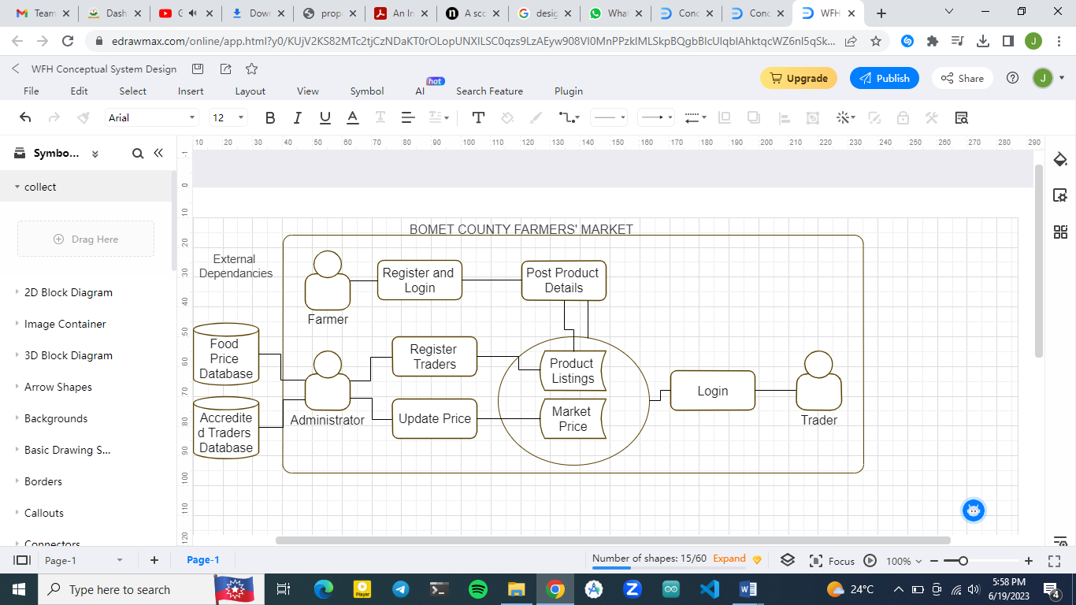

Figure 1 Design Framework

**CHAPTER THREE**

**RESEARCH DESIGN AND METHODOLOGY**

**3.1 Introduction**

This chapter explores the research methodology that was used to conduct the study. It also details the location where the study was carried out as well as the population that participated in the study. The sampling procedure is also highlighted. The data collection procedure is also be stated in this chapter. The system development methodology which include the programming methodology are detailed in this chapter. This chapter also contains the system analysis and design diagrams.

**3.2 Research Design**

This project implemented the experimental research design. This is where the study tried to prove the cause and effect relationship between some variables. The variable that was used in this case was the introduction of an android mobile application. The effect to be tested was whether the use of this application by banana farmers would lead to the increase in sales volumes for the banana farmers.

**3.3 Location of Study**This study was conducted in the County of Bomet of the Republic of Kenya. This study was conducted in all the 5 sub counties and 25 Wards of Bomet County.

This location was chosen because of the climatic conditions which support the growth and sustainability of bananas. Banana plants do well in all the 25 wards and thus if the solution from this study could be successfully implemented, it would impact a vast majority of the population of the county. This location was also chosen since the banana crop had been identified by the county as a VCC and thus this study would supplement the already existing studies regarding the same.

**3.4 Population of the Study**

In Bomet County, 86% of the households had formal ownership of land. This meant that they could engage in voluntary cultivation of crops. This is a total of 122,430 households. Of these, 61% of the households were involve in the banana cultivation value chain. This brought a total of 74, 682 households that had in some way benefited or intended to benefit from banana cultivation. (MoALF. 2017)

**3.5 Sampling procedure and sample size**

**3.5.1 Sampling Procedure**

This project used the random sampling technique. The study used social media and word of mouth to reach out to banana farmers in the study location. Willing farmers would be on-boarded to undertake the study.

**3.5.2 Sample size**

This study then randomly picked from the willing participants. 10 participants from each of the 25 wards of the county were selected. This brought to a total the number of farmers chosen to be 250. This was the sample size.

**3.6 Data Collection Procedure**

This project made use of questionnaires. This is a very simple method used to collect data. This is because the user is prompted by several questions to reveal the data that would be useful for the study. For this study, closed ended questions were utilized. This made it easier to capture the specific required data as compared to the use of open ended questionnaires.

For this study, the questionnaires were administered in an online format. This study employed the use of Google Forms to structure the questionnaire and provide a storage mechanism to capture generated data. This was a very convenient method to both the targeted farmer as well as the person collecting the data. It eliminated the logistical expenses associated with travel. Covering all the wards in the county would have been an expensive affair. The data collected was also stored and could be easily analyzed using online tools. This is opposed to the physical questionnaires where it would take some time for data entry to the analysis software.

Once the data had been analyzed, conclusions could then be drawn.

**3.7 System Development Methodology**

This project used the prototype system development methodology. This methodology was used to implement the final solution of this project.

Prototype methodology is an incremental model of development. In this methodology, a first product known as the prototype is developed with some of the features that are intended. Once this is developed, the product is passed to a sample of identified users to use and assess it. The users do all sorts of testing as they use the prototype.

Feedback from users is collected and this feedback helps the developer to rework the product. The product is modified so as to include the features that users suggest. Corrections are also made to the functionalities.

This process is repeated until a final product that is acceptable to the user is acquired.

The advantage of this methodology is that once the developer has the system requirements, they can start its development. Modifications are easy to implement since it does not entail the overhaul of the whole system but rather specific parts depending on the analysis of the users who determine the strengths and weaknesses which are then corrected.

**3.8 System Analysis and Design**

**3.8.1 Context Diagram**

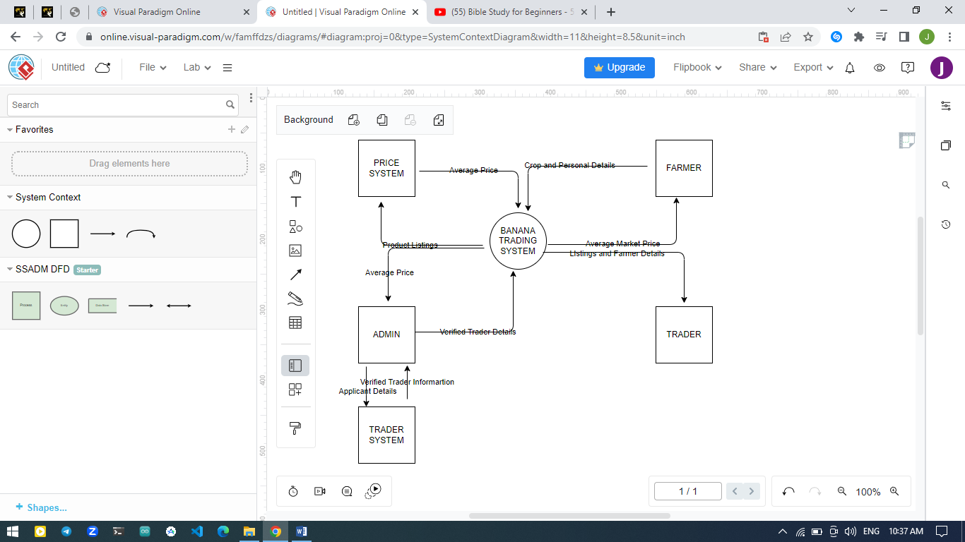

Figure 2 Context Diagram

**3.8.2 Level 1 DFD**

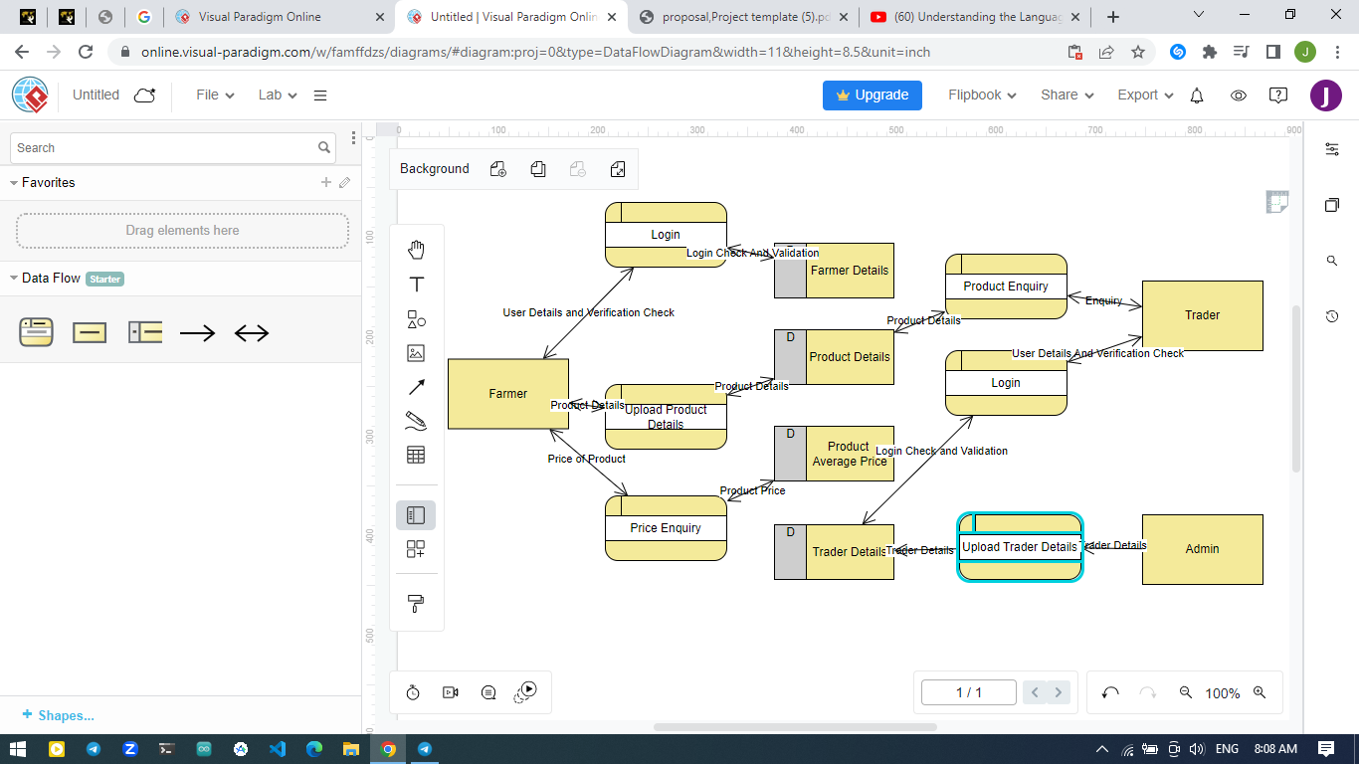

Figure 3 Level 1 DFD

# CHAPTER 4

**SYSTEM IMPLEMENTATION AND DEPLOYMENT**

## Introduction

This chapter covers how the system will be utilized by the end user. It includes the relevant user interfaces as well as the relevant code that enables the system to execute its functions. It will also cover the backend development logic.

## System Architecture

This system includes a front end and backend. The frontend consists of the interfaces that are directly accessed by the farmer. The backend covers the database that stores the user input. This data when retrieved is displayed in the frontend.

## User Interface Design

This system implements the graphical user interface design. In this design the user interacts with the system by clicking on buttons and links. Once clicked, the user is able to either save data or navigate the system.

## Frontend Development

This section contains the user interfaces that are accessible by the farmer to execute various functions.

### **Landing Page**

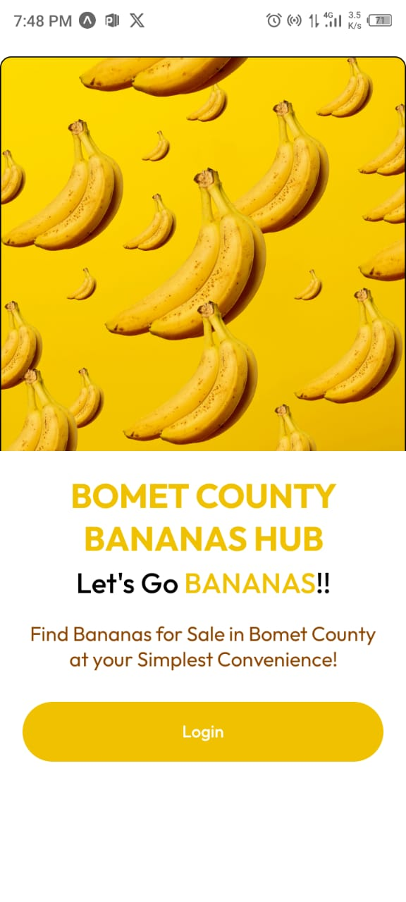

Figure 4 Landing page

* + 1. **Authenticatio**n

This system utilized Clerk OAuth for easy and seamless Login and Signup

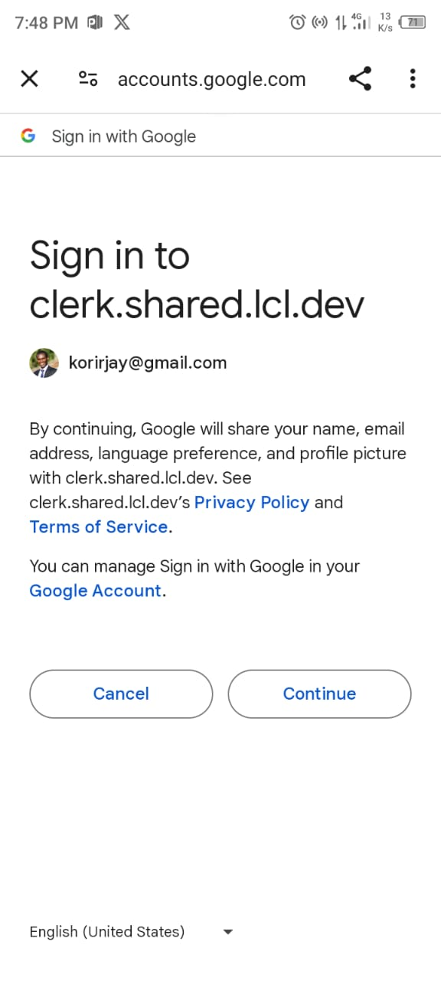

Figure 5 Authentication

* + 1. **Add Product**

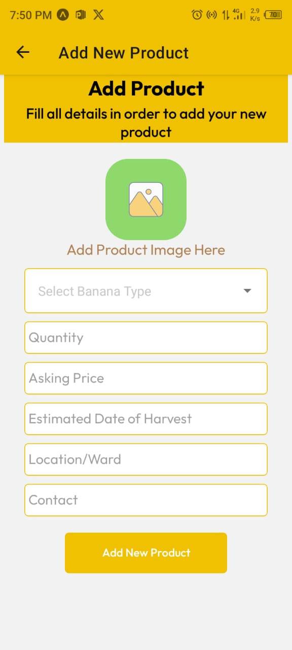

Figure 6 Add Product page

* + 1. **My Products**

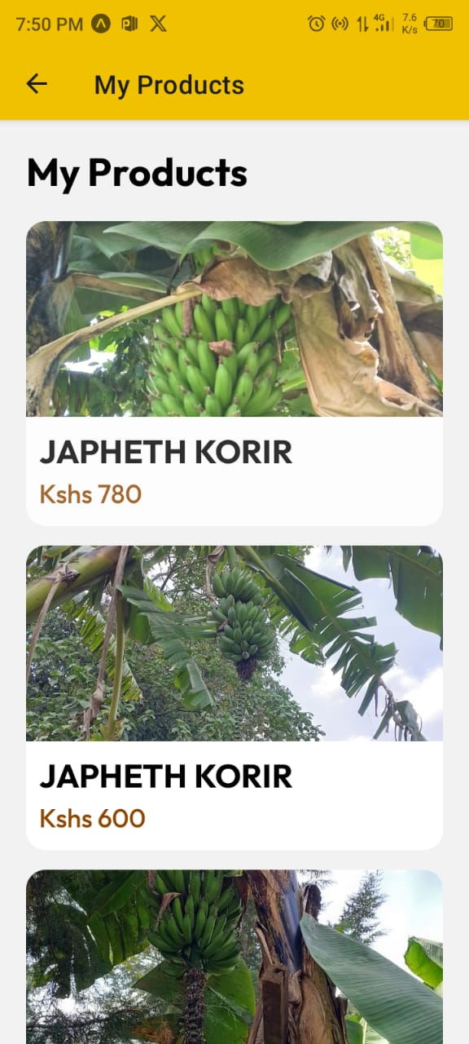

Figure 7 My products page

* + 1. **Home Page**

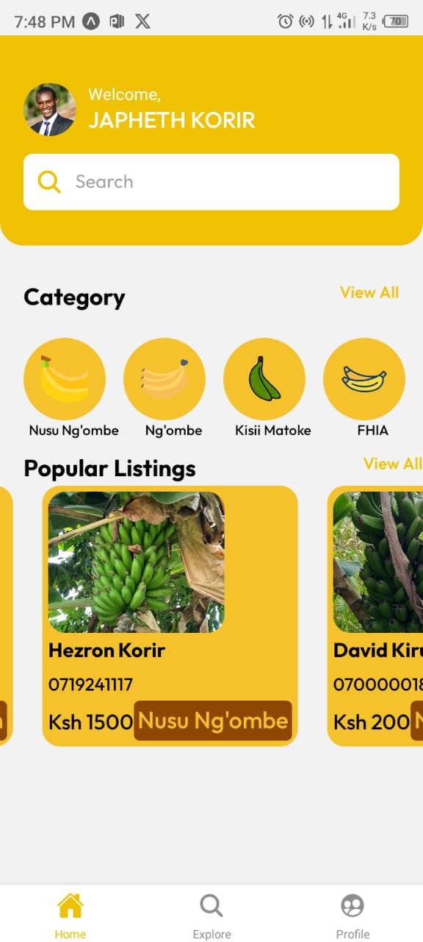

Figure 8 Home Page

* + 1. **Category**

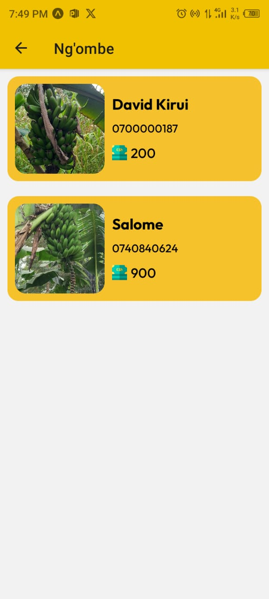

Figure 9 Category Page

* + 1. **Product Details**

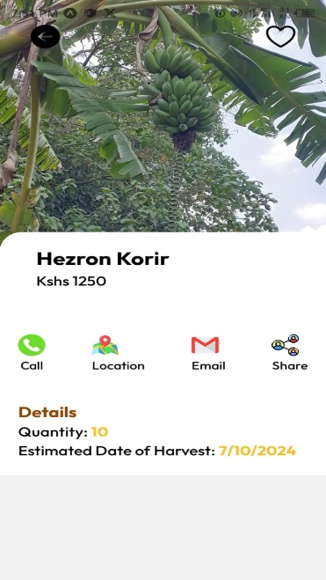

Figure 10 Product Details Page

* + 1. **User Account**

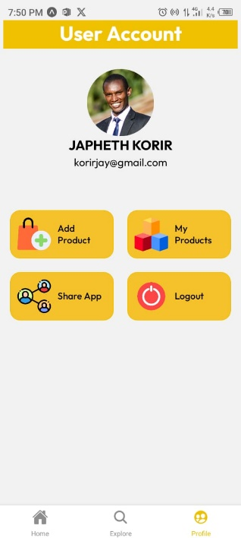

Figure 11 User Account Page

* + 1. **Frontend Code**

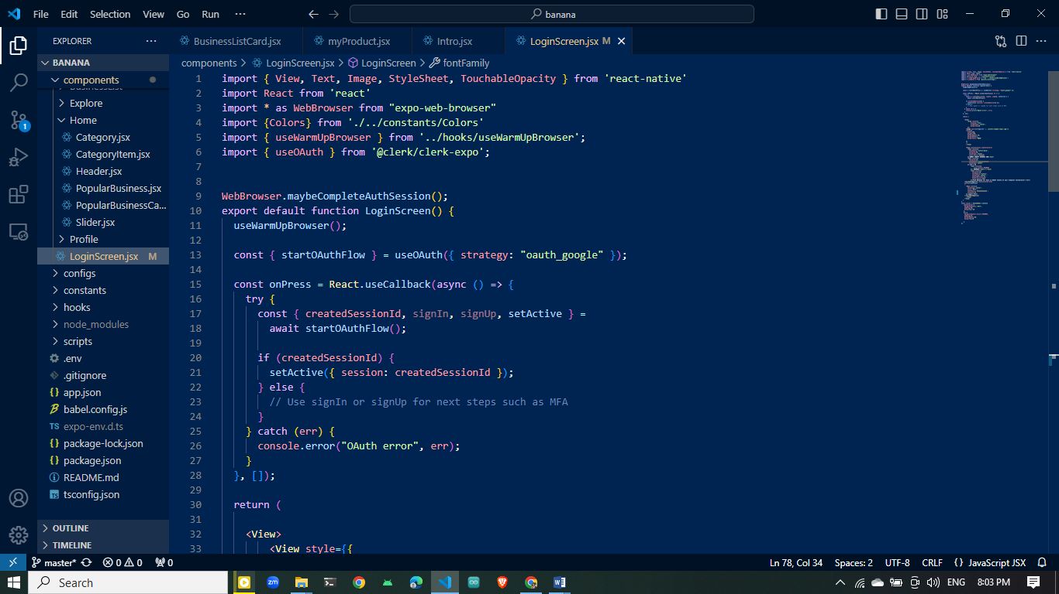

Figure 12 Code for authentication and login using Clerk using OAuth internet protocol

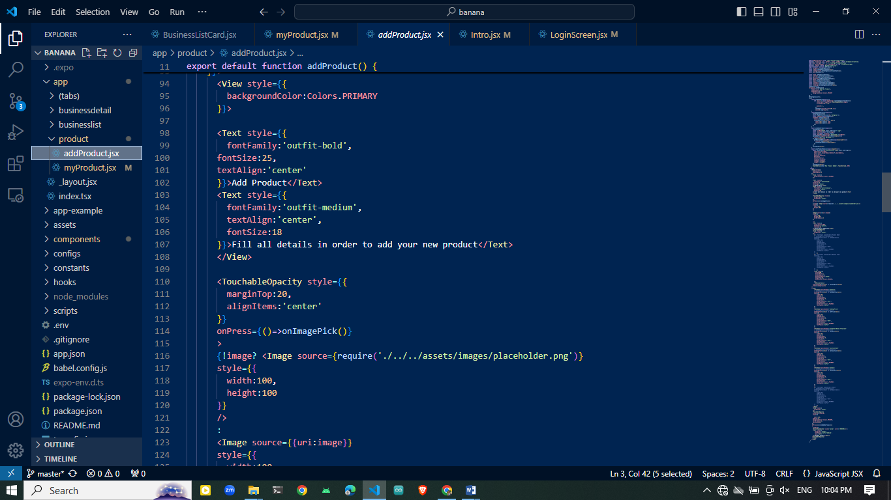

Figure 13 Part of code to add product

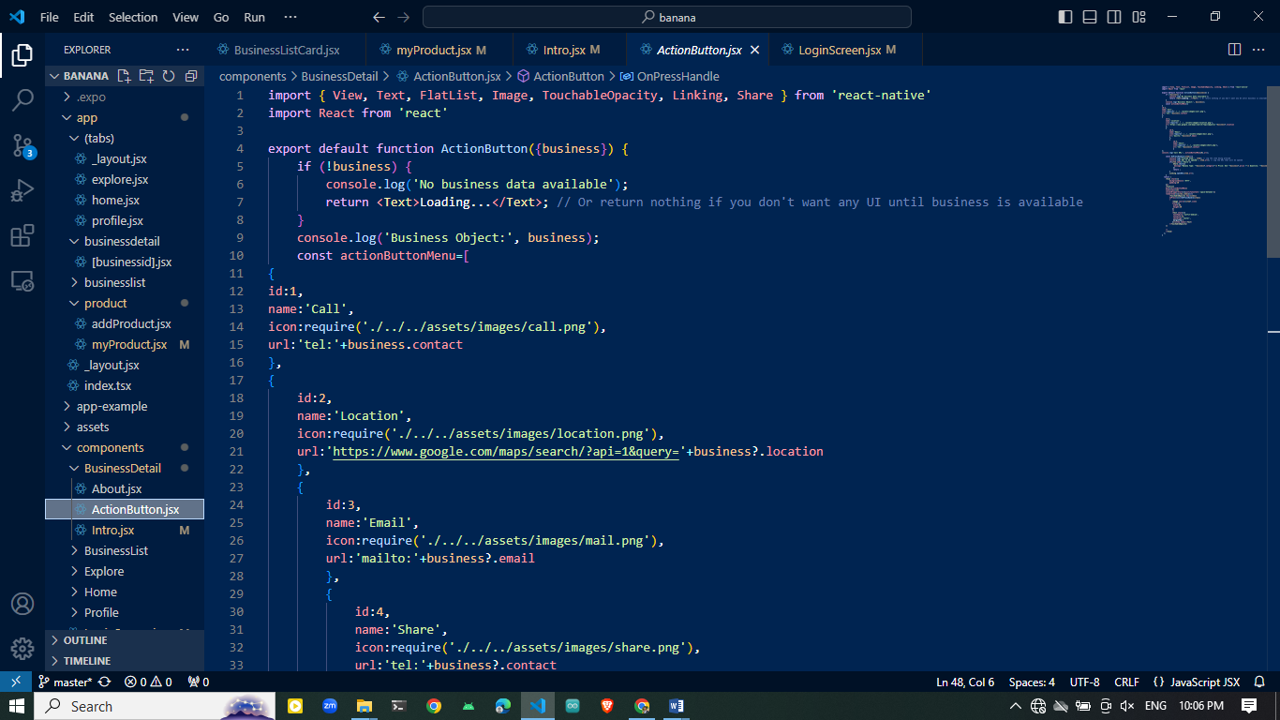

Figure 14 Part of code to display product details

* 1. **Backend Development**

This contains database details. This project utilized Firebase Database for storage. This is due to the fact that the firebase support real-time data query and addition which is crucial for the project.

**4.5.1 Screenshots of Database**

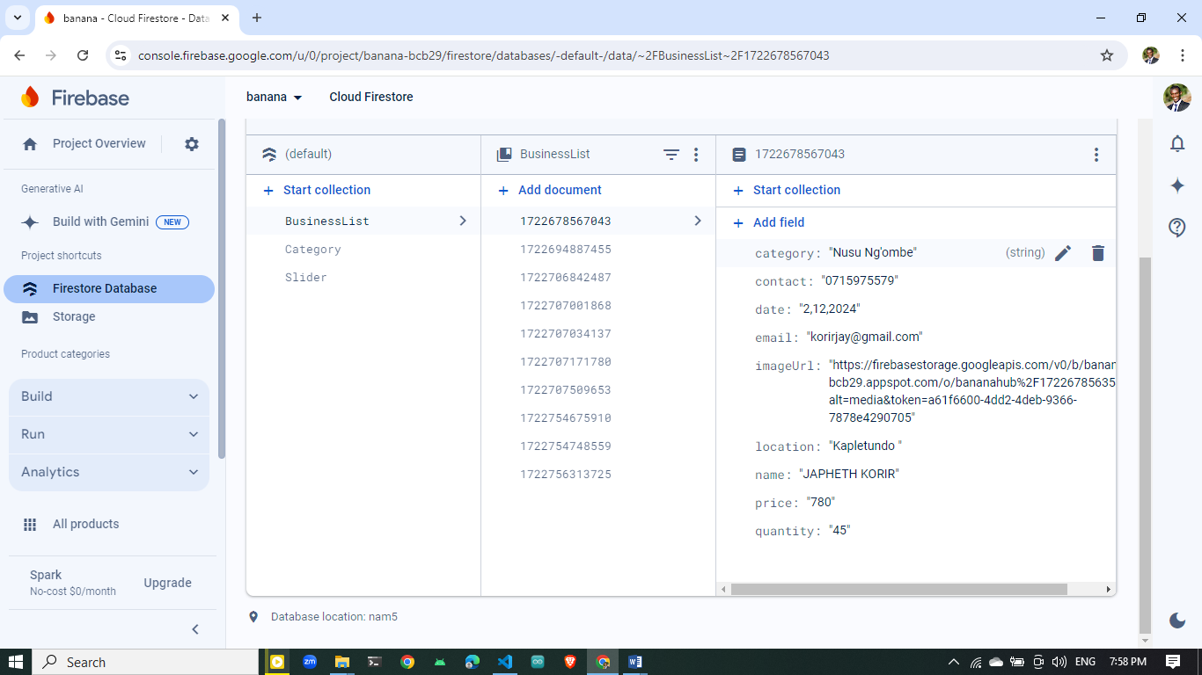

Figure 15 Backend Firebase Database with user input captured

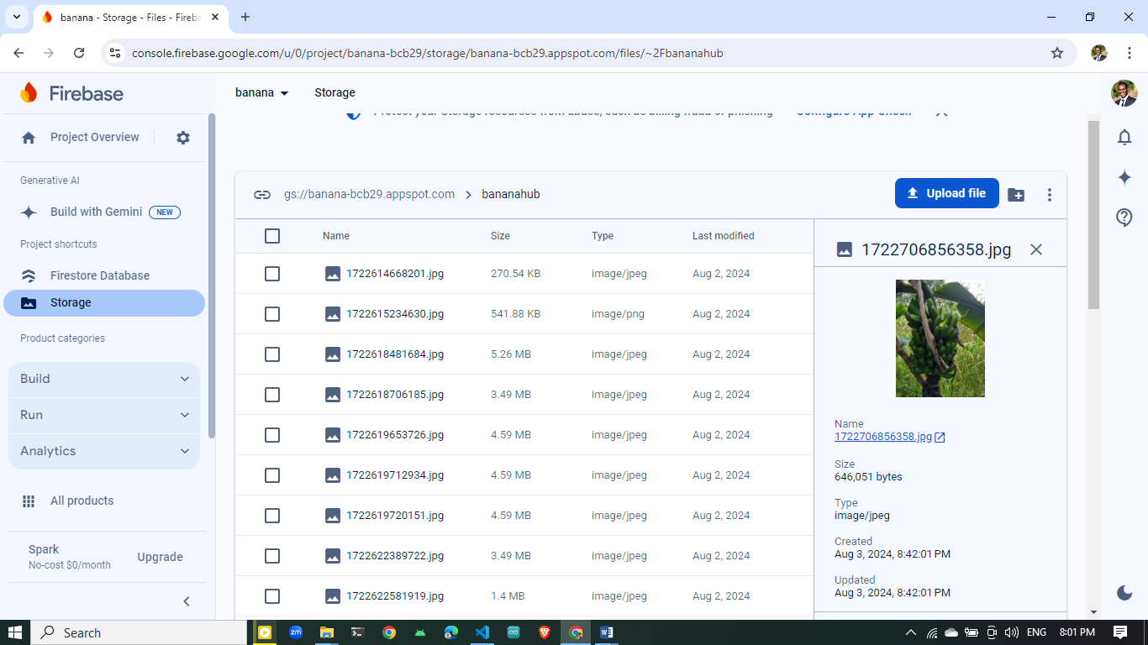

Figure 16 Product image stored in firebase Storage

**4.5.2 Backend Code**

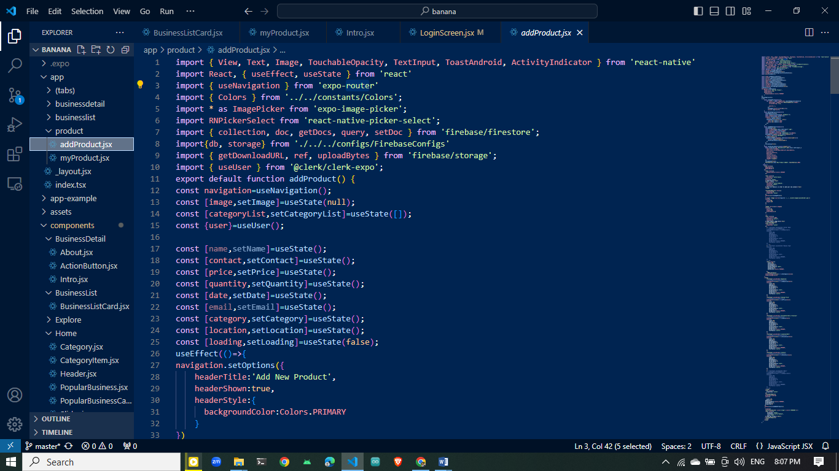

Figure 17 Part of code to write farmer details data to the firebase database

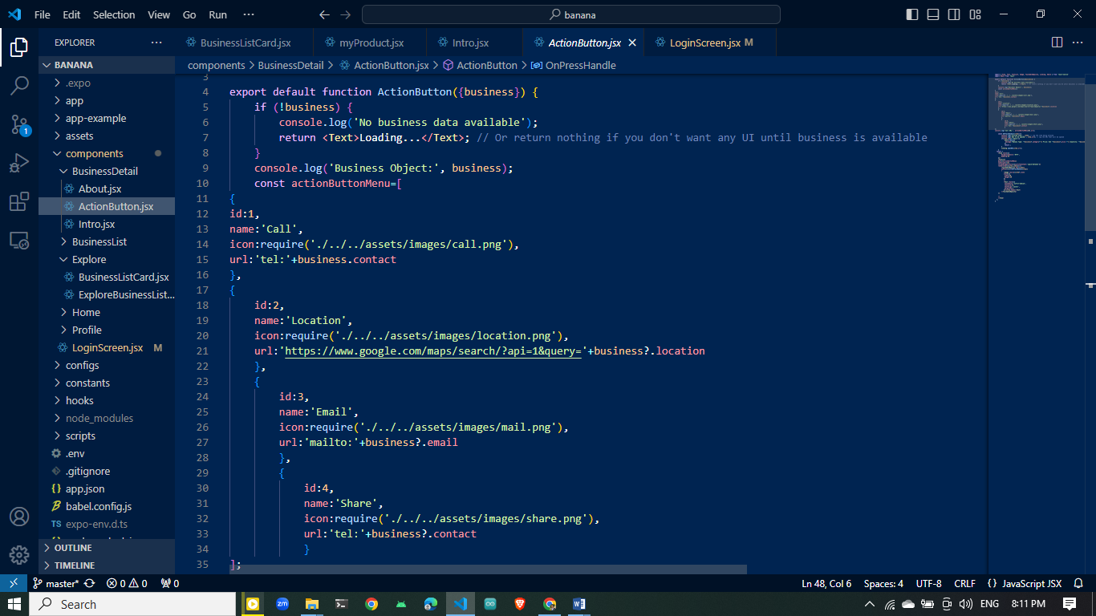

Figure 18 Part of code to query product and farmer details from database and display on the product details page

* 1. **Deployment Method**

The system currently runs on Expo Go. This is a platform that supports react Native applications by providing development and runtime environments.

# CHAPTER 5

# 5.1 Conclusion and Future Work

Having confirmed that the system is fully functional, it can be deployed into production. This will be highly beneficial to all banana farmers in the County.

Due to the robustness of the system, other modules can be integrated in the future to provide more functionality.

# 5.2 Schedule

|  |  |
| --- | --- |
| TIMELINE | ACTIVITY |
| May 12-August 1 2024 | System Development |
| May 12-August 1 2024 | Documentation |

Table 1 Schedule

# 5.3 Budget

|  |  |
| --- | --- |
| ITEM | COST |
| Printing of Documentation | 10*40  Kshs 400 |
| Binding of Document | Kshs 70 |
| TOTAL | Kshs 470 |

Table 2 Budget

**5.4 REFERENCES**

Bernstein, S. (2017) ‘The United Nations and the governance of Sustainable Development Goals’, *Governing through Goals*, 1(1), pp. 213–239.

Gassner, A. *et al.* (2019) ‘Poverty eradication and food security through agriculture in Africa: Rethinking objectives and entry points’, *Outlook on Agriculture*, 48(4), pp. 309–315.

Khonje, M.G. *et al.* (2022) ‘Farm-level production diversity and child and adolescent nutrition in rural sub-Saharan africa: A Multicountry, longitudinal study’, *The Lancet Planetary Health*, 6(5), pp. 391–399.

Liverpool-Tasie, L.S. *et al.* (2020) ‘A scoping review of market links between value chain actors and small-scale producers in developing regions’, *Nature Sustainability*, 3(10), pp. 799–808.

Mellor, J.W. (2017) ‘The Economic Transformation’, *Agricultural Development and Economic Transformation*, 1(2), pp. 17–28.

MoALF. (2017). Climate Risk Profile for Bomet County. Kenya County Climate Risk Profile Series. The Ministry of Agriculture, Livestock and Fisheries

Omari, E.N. *et al.* (2024) ‘Assessing the advantages of tissue culture bananas technology production of banana farmers in Kisii County, Kenya’, *Environmental Challenges*, 14(100843), pp. 273–301.

Pereira, L. (2017) ‘Climate change impacts on agriculture across Africa’, *Oxford Research Encyclopedia of Environmental Science*, 5(14), pp. 139–151.